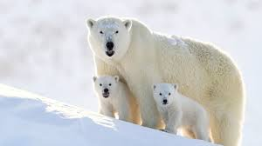Object Oriented Programming

Class: Bear

Properties:

1. Have claws.
2. Carnivore
3. Mammals
4. Weight

Behaviour:

1.Eat()

2.Play()

3.Hunt()

4.Walk()

|  |
| --- |
| BEAR |
| Properties:  Have claws :boolean  Carnivore :boolean  Mammals :boolean  Weight :int |
| Behaviour:  Eat( ) :void  Play():void  Hunt():void  Walk():void |

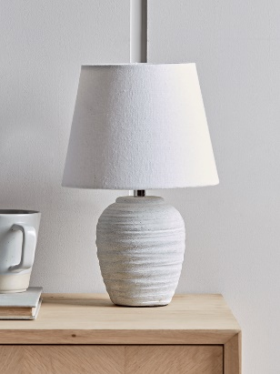

|  |
| --- |
| Lamp |
| Properties:  1. Voltage: double  2. Colour Temperature: double  3. Intensity : double  4. Mean Life : int |
| Behaviour:  1.heating( ):void  2.lights() :void  3.electricity() :void |

Behaviour:

1.heating()

2.lights()

3.electricity()

Properties:

1. Voltage

2. Colour Temperature

3. Intensity

4. Mean Life

Class: Lamp

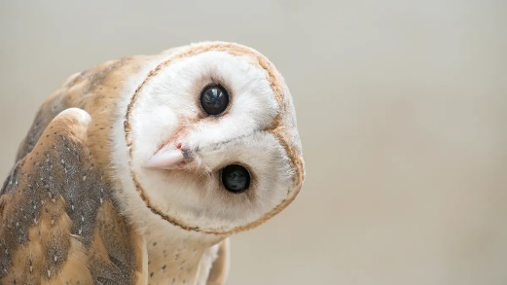

Class: Bird

Behaviour:

1. Dive()
2. Jump()
3. Fly()

|  |
| --- |
| Bird |
| Properties:   1. Wings: boolean 2. Size :double 3. Breed :string |
| Behaviour:   1. Dive() :void 2. Jump() :void 3. Fly() :void |

Properties:

1. Wings
2. Size
3. Breed

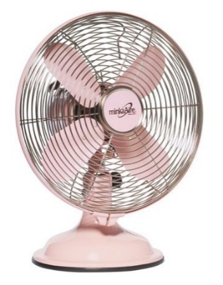

Class: Fan

Behaviour:

1. Electricity()
2. Wind()
3. Cold()

Properties:

1. Brand
2. Size
3. Windpower

|  |
| --- |
| Fan |
| Properties:   1. Brand : string 2. Size : double 3. Windpower : double |
| Behaviour:   1. Electricity ():void 2. Wind ():void 3. Cold ():void |



|  |
| --- |
| Pen |
| Properties:   1. Brand : string 2. Type :string 3. Size: double |
| Behaviour:   1. Writing ():void 2. Doodling ():void 3. Drawing ():void 4. Sketching ():void |

Behaviour:

1. Writing()
2. Doodling()
3. Drawing()
4. Sketching()

Properties:

1. Brand
2. Type
3. Size

Class: Pen